WEEK 3 PROJECT REPORT
Seller and Inventory Management System
E-Commerce Database Management System
Submitted By
Name: ____sandhiya.R__________________________
Register No.: ____E25AI140___________________
Class / Department: ____BSC CS WITH AI____________

1. Introduction

The Seller and Inventory Management System is a database project for an e-commerce company. The system maintains seller details, tracks products supplied by sellers, and monitors inventory levels to manage product availability

Database Design

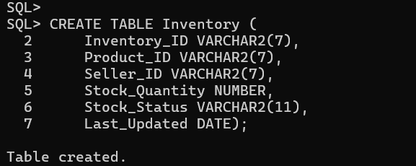
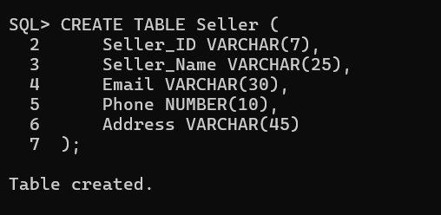

Seller Email Constraints
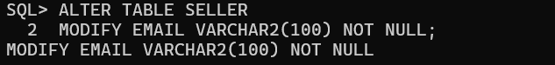

inventory Table
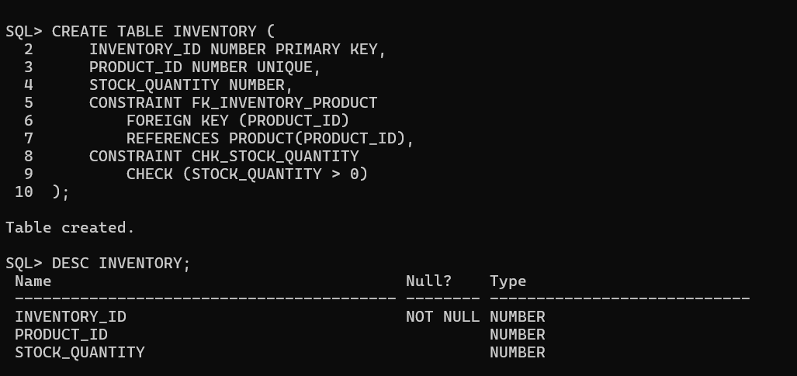
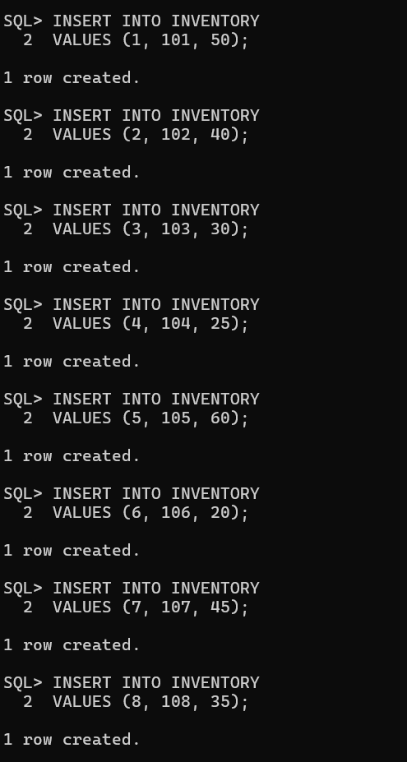

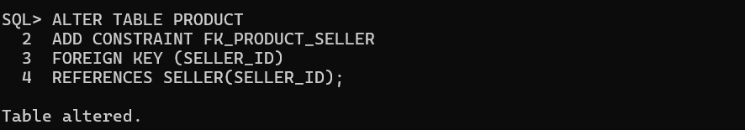

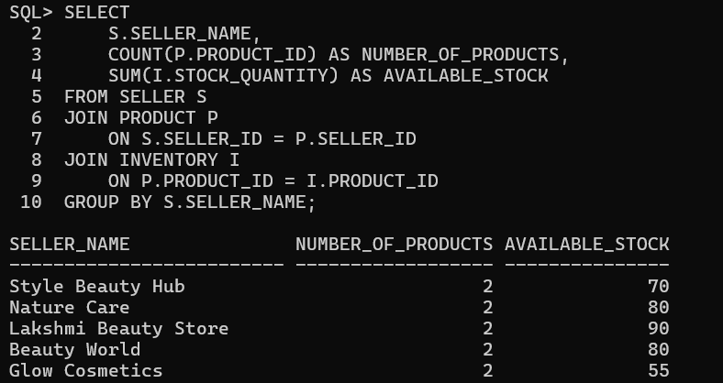

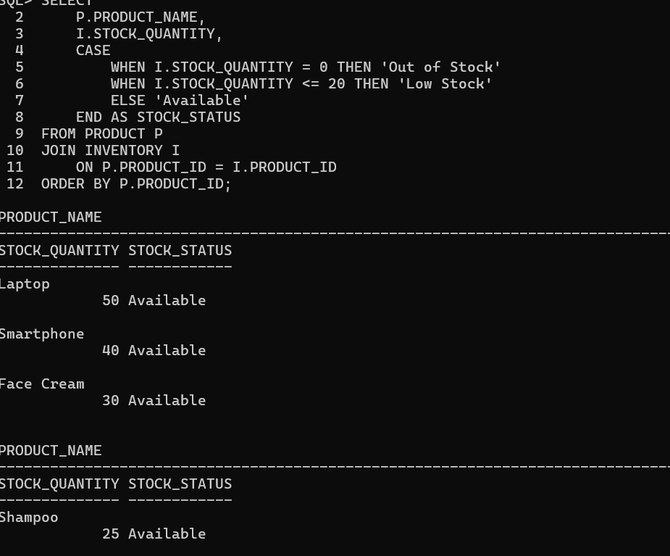
Stock Availability Report

IVENTORY ANALYSIS:
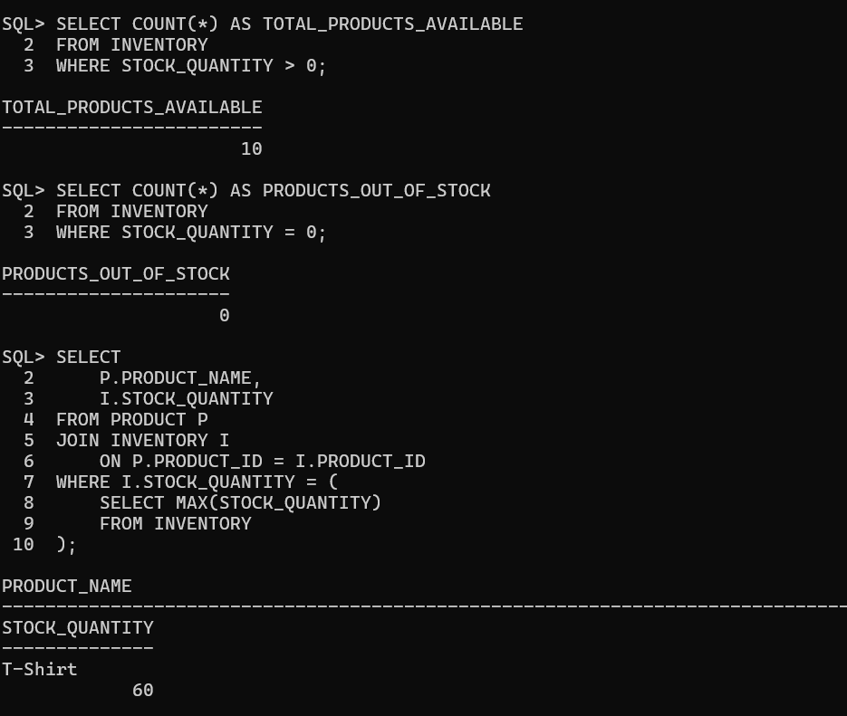

Average Inventory Quantity
